

MATHEMATICAL MODELING

lecturer of q-class: prof. dr. basuki widodo, m.sc

2nd quiz | **Venansius ryan tjahjono 06111540000043**

Departemen Matematika

Fakultas Matematika, Komputasi, dan Sains Data

Institut Teknologi Sepuluh Nopember

Surabaya 2018

# **SKYDIVING PROBLEM – SIMULATION WITH MATLAB**

SOURCE CODE

function varargout = SkydiverSimulation(varargin)

% SKYDIVERSIMULATION MATLAB code for SkydiverSimulation.fig

% SKYDIVERSIMULATION, by itself, creates a new SKYDIVERSIMULATION or raises the existing

% singleton*.

%

% H = SKYDIVERSIMULATION returns the handle to a new SKYDIVERSIMULATION or the handle to

% the existing singleton*.

%

% SKYDIVERSIMULATION('CALLBACK',hObject,eventData,handles,...) calls the local

% function named CALLBACK in SKYDIVERSIMULATION.M with the given input arguments.

%

% SKYDIVERSIMULATION('Property','Value',...) creates a new SKYDIVERSIMULATION or raises the

% existing singleton*. Starting from the left, property value pairs are

% applied to the GUI before SkydiverSimulation_OpeningFcn gets called. An

% unrecognized property name or invalid value makes property application

% stop. All inputs are passed to SkydiverSimulation_OpeningFcn via varargin.

%

% *See GUI Options on GUIDE's Tools menu. Choose "GUI allows only one

% instance to run (singleton)".

%

% See also: GUIDE, GUIDATA, GUIHANDLES

% Edit the above text to modify the response to help SkydiverSimulation

% Last Modified by GUIDE v2.5 28-Nov-2018 22:50:13

% Begin initialization code - DO NOT EDIT

gui_Singleton = 1;

gui_State = struct('gui_Name', mfilename, ...

'gui_Singleton', gui_Singleton, ...

'gui_OpeningFcn', @SkydiverSimulation_OpeningFcn, ...

'gui_OutputFcn', @SkydiverSimulation_OutputFcn, ...

'gui_LayoutFcn', [] , ...

'gui_Callback', []);

if nargin && ischar(varargin{1})

gui_State.gui_Callback = str2func(varargin{1});

end

if nargout

[varargout{1:nargout}] = gui_mainfcn(gui_State, varargin{:});

else

gui_mainfcn(gui_State, varargin{:});

end

% End initialization code - DO NOT EDIT

% --- Executes just before SkydiverSimulation is made visible.

function SkydiverSimulation_OpeningFcn(hObject, eventdata, handles, varargin)

% This function has no output args, see OutputFcn.

% hObject handle to figure

% eventdata reserved - to be defined in a future version of MATLAB

% handles structure with handles and user data (see GUIDATA)

% varargin command line arguments to SkydiverSimulation (see VARARGIN)

% Choose default command line output for SkydiverSimulation

handles.output = hObject;

axes(handles.axes1)

imshow('picits1.png')

axes(handles.axes2)

imshow('picmath1.png')

axes(handles.axes3)

xlabel('OBSERVED TIME','FontSize',10,'FontWeight','bold','Color','w');

ylabel('VELOCITY','FontSize',10,'FontWeight','bold','Color','w');

set(handles.axes3, 'XColor', 'w');

set(handles.axes3, 'YColor', 'w');

% Update handles structure

guidata(hObject, handles);

% UIWAIT makes SkydiverSimulation wait for user response (see UIRESUME)

% uiwait(handles.figure1);

% --- Outputs from this function are returned to the command line.

function varargout = SkydiverSimulation_OutputFcn(hObject, eventdata, handles)

% varargout cell array for returning output args (see VARARGOUT);

% hObject handle to figure

% eventdata reserved - to be defined in a future version of MATLAB

% handles structure with handles and user data (see GUIDATA)

% Get default command line output from handles structure

varargout{1} = handles.output;

function edit1_Callback(hObject, eventdata, handles)

% hObject handle to edit1 (see GCBO)

% eventdata reserved - to be defined in a future version of MATLAB

% handles structure with handles and user data (see GUIDATA)

% Hints: get(hObject,'String') returns contents of edit1 as text

% str2double(get(hObject,'String')) returns contents of edit1 as a double

% --- Executes during object creation, after setting all properties.

function edit1_CreateFcn(hObject, eventdata, handles)

% hObject handle to edit1 (see GCBO)

% eventdata reserved - to be defined in a future version of MATLAB

% handles empty - handles not created until after all CreateFcns called

% Hint: edit controls usually have a white background on Windows.

% See ISPC and COMPUTER.

if ispc && isequal(get(hObject,'BackgroundColor'), get(0,'defaultUicontrolBackgroundColor'))

set(hObject,'BackgroundColor','white');

end

function edit4_Callback(hObject, eventdata, handles)

% hObject handle to edit4 (see GCBO)

% eventdata reserved - to be defined in a future version of MATLAB

% handles structure with handles and user data (see GUIDATA)

% Hints: get(hObject,'String') returns contents of edit4 as text

% str2double(get(hObject,'String')) returns contents of edit4 as a double

% --- Executes during object creation, after setting all properties.

function edit4_CreateFcn(hObject, eventdata, handles)

% hObject handle to edit4 (see GCBO)

% eventdata reserved - to be defined in a future version of MATLAB

% handles empty - handles not created until after all CreateFcns called

% Hint: edit controls usually have a white background on Windows.

% See ISPC and COMPUTER.

if ispc && isequal(get(hObject,'BackgroundColor'), get(0,'defaultUicontrolBackgroundColor'))

set(hObject,'BackgroundColor','white');

end

function edit5_Callback(hObject, eventdata, handles)

% hObject handle to edit5 (see GCBO)

% eventdata reserved - to be defined in a future version of MATLAB

% handles structure with handles and user data (see GUIDATA)

% Hints: get(hObject,'String') returns contents of edit5 as text

% str2double(get(hObject,'String')) returns contents of edit5 as a double

% --- Executes during object creation, after setting all properties.

function edit5_CreateFcn(hObject, eventdata, handles)

% hObject handle to edit5 (see GCBO)

% eventdata reserved - to be defined in a future version of MATLAB

% handles empty - handles not created until after all CreateFcns called

% Hint: edit controls usually have a white background on Windows.

% See ISPC and COMPUTER.

if ispc && isequal(get(hObject,'BackgroundColor'), get(0,'defaultUicontrolBackgroundColor'))

set(hObject,'BackgroundColor','white');

end

% --- Executes on button press in pushbutton1.

function pushbutton1_Callback(hObject, eventdata, handles)

% hObject handle to pushbutton1 (see GCBO)

% eventdata reserved - to be defined in a future version of MATLAB

% handles structure with handles and user data (see GUIDATA)

tic;

m = str2num(get(handles.edit1,'String'));

c = str2num(get(handles.edit4,'String'));

t = str2num(get(handles.edit5,'String'));

T = 0:t;

v = [];

g = 9.8;

for i = T

v(i+1) = (m*g/c)*(1-exp(-c*i/m));

end

plot(T,v);

xlabel('OBSERVED TIME','FontSize',10,'FontWeight','bold','Color','w');

ylabel('VELOCITY','FontSize',10,'FontWeight','bold','Color','w');

set(handles.axes3, 'XColor', 'w');

set(handles.axes3, 'YColor', 'w');

set(handles.edit8, 'String', round(toc*10000)/10000)

% --- Executes on button press in pushbutton2.

function pushbutton2_Callback(hObject, eventdata, handles)

% hObject handle to pushbutton2 (see GCBO)

% eventdata reserved - to be defined in a future version of MATLAB

% handles structure with handles and user data (see GUIDATA)

set(handles.edit1, 'String', '')

set(handles.edit4, 'String', '')

set(handles.edit5, 'String', '')

set(handles.edit8, 'String', '')

cla(handles.axes3)

function edit8_Callback(hObject, eventdata, handles)

% hObject handle to edit8 (see GCBO)

% eventdata reserved - to be defined in a future version of MATLAB

% handles structure with handles and user data (see GUIDATA)

% Hints: get(hObject,'String') returns contents of edit8 as text

% str2double(get(hObject,'String')) returns contents of edit8 as a double

% --- Executes during object creation, after setting all properties.

function edit8_CreateFcn(hObject, eventdata, handles)

% hObject handle to edit8 (see GCBO)

% eventdata reserved - to be defined in a future version of MATLAB

% handles empty - handles not created until after all CreateFcns called

% Hint: edit controls usually have a white background on Windows.

% See ISPC and COMPUTER.

if ispc && isequal(get(hObject,'BackgroundColor'), get(0,'defaultUicontrolBackgroundColor'))

set(hObject,'BackgroundColor','white');

end

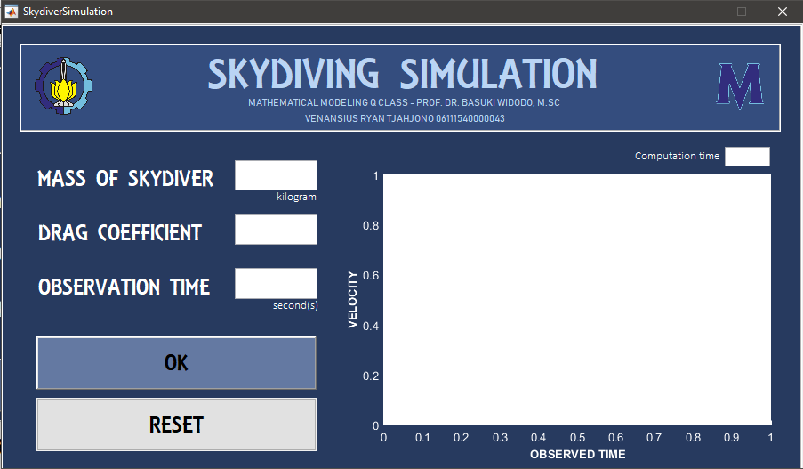

GRAPHICAL USER INTERFACE

SIMULATION RESULT WITH VARIOUS MASS OF SKYDIVER AND DRAG COEFFICIENT = 0.42

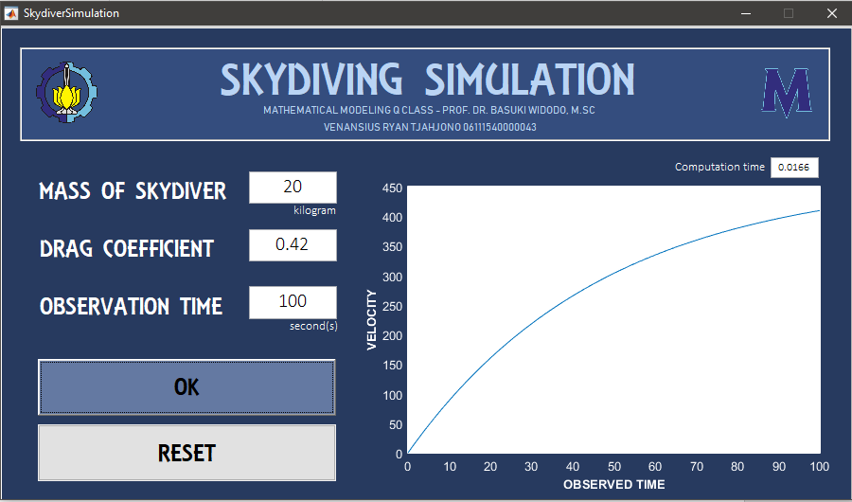

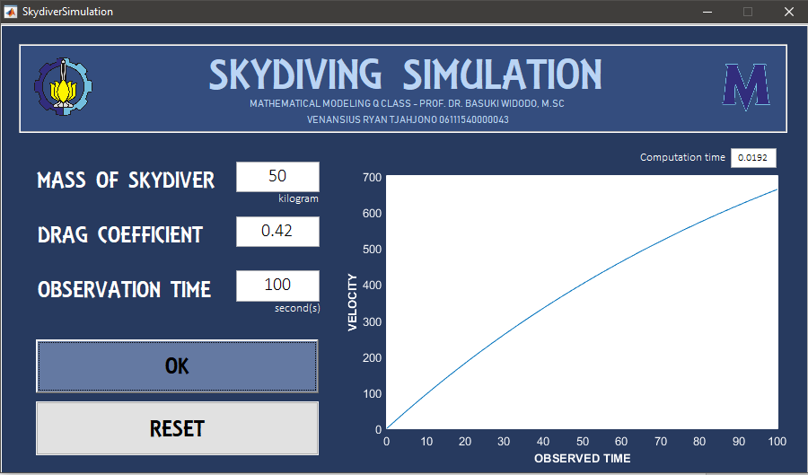

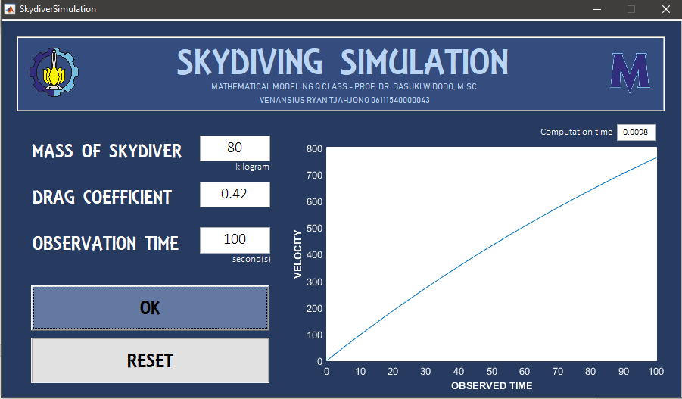

SIMULATION RESULT WITH VARIOUS DRAG COEFFICIENT AND MASS OF SKYDIVER = 70 KG

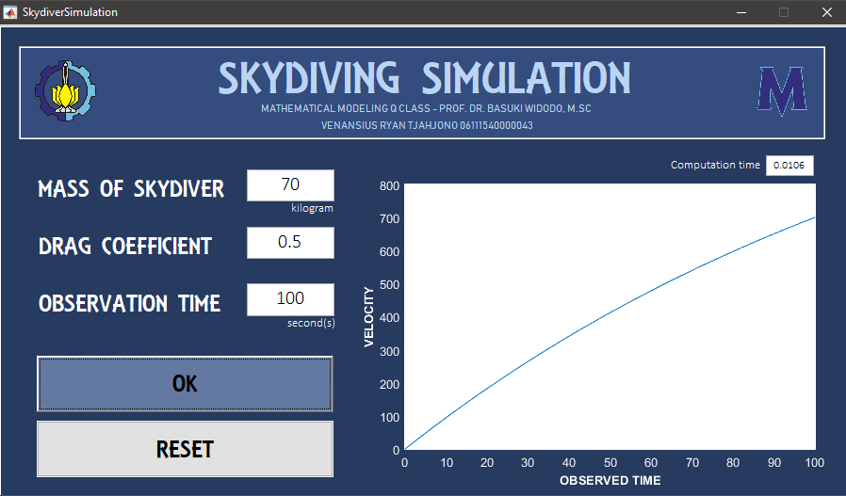

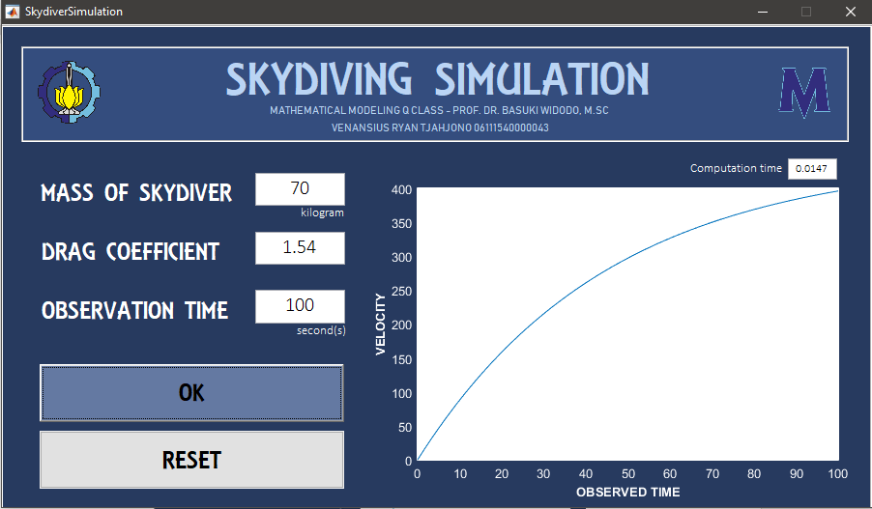

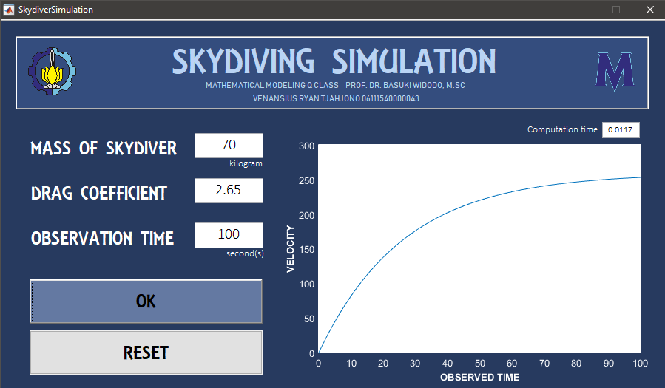

CONCLUSION

As a skydiver falls, he accelerates downwards, gaining speed with each second. The increase in speed is accompanied by an increase in air resistance (as observed in the animation below). This force of air resistance counters the force of gravity. As the skydiver falls faster and faster, the amount of air resistance increases more and more until it approaches the magnitude of the force of gravity. Once the force of air resistance is as large as the force of gravity, a balance of forces is attained and the skydiver no longer accelerates. The skydiver is said to have reached a terminal velocity.

# **MUSICAL INSTRUMENT STRING PROBLEM – SIMULATION WITH MATLAB**

SOUCE CODE

function varargout = StringSimulationGui(varargin)

% STRINGSIMULATIONGUI MATLAB code for StringSimulationGui.fig

% STRINGSIMULATIONGUI, by itself, creates a new STRINGSIMULATIONGUI or raises the existing

% singleton*.

%

% H = STRINGSIMULATIONGUI returns the handle to a new STRINGSIMULATIONGUI or the handle to

% the existing singleton*.

%

% STRINGSIMULATIONGUI('CALLBACK',hObject,eventData,handles,...) calls the local

% function named CALLBACK in STRINGSIMULATIONGUI.M with the given input arguments.

%

% STRINGSIMULATIONGUI('Property','Value',...) creates a new STRINGSIMULATIONGUI or raises the

% existing singleton*. Starting from the left, property value pairs are

% applied to the GUI before StringSimulationGui_OpeningFcn gets called. An

% unrecognized property name or invalid value makes property application

% stop. All inputs are passed to StringSimulationGui_OpeningFcn via varargin.

%

% *See GUI Options on GUIDE's Tools menu. Choose "GUI allows only one

% instance to run (singleton)".

%

% See also: GUIDE, GUIDATA, GUIHANDLES

% Edit the above text to modify the response to help StringSimulationGui

% Last Modified by GUIDE v2.5 28-Nov-2018 20:19:52

% Begin initialization code - DO NOT EDIT

gui_Singleton = 1;

gui_State = struct('gui_Name', mfilename, ...

'gui_Singleton', gui_Singleton, ...

'gui_OpeningFcn', @StringSimulationGui_OpeningFcn, ...

'gui_OutputFcn', @StringSimulationGui_OutputFcn, ...

'gui_LayoutFcn', [] , ...

'gui_Callback', []);

if nargin && ischar(varargin{1})

gui_State.gui_Callback = str2func(varargin{1});

end

if nargout

[varargout{1:nargout}] = gui_mainfcn(gui_State, varargin{:});

else

gui_mainfcn(gui_State, varargin{:});

end

% End initialization code - DO NOT EDIT

% --- Executes just before StringSimulationGui is made visible.

function StringSimulationGui_OpeningFcn(hObject, eventdata, handles, varargin)

% This function has no output args, see OutputFcn.

% hObject handle to figure

% eventdata reserved - to be defined in a future version of MATLAB

% handles structure with handles and user data (see GUIDATA)

% varargin command line arguments to StringSimulationGui (see VARARGIN)

% Choose default command line output for StringSimulationGui

handles.output = hObject;

axes(handles.axes2);

imshow('picits1.png');

axes(handles.axes3);

imshow('picmath1.png');

axes(handles.axes4);

xlabel('TIME','FontSize',10,'FontWeight','bold','Color','k');

ylabel('DEFLECTION','FontSize',10,'FontWeight','bold','Color','k');

axes(handles.axes1);

xlabel('TIME','FontSize',10,'FontWeight','bold','Color','k');

ylabel('DEFLECTION','FontSize',10,'FontWeight','bold','Color','k');

% Update handles structure

guidata(hObject, handles);

% UIWAIT makes StringSimulationGui wait for user response (see UIRESUME)

% uiwait(handles.figure1);

% --- Outputs from this function are returned to the command line.

function varargout = StringSimulationGui_OutputFcn(hObject, eventdata, handles)

% varargout cell array for returning output args (see VARARGOUT);

% hObject handle to figure

% eventdata reserved - to be defined in a future version of MATLAB

% handles structure with handles and user data (see GUIDATA)

% Get default command line output from handles structure

varargout{1} = handles.output;

% --- Executes on button press in pushbutton1.

function pushbutton1_Callback(hObject, eventdata, handles)

% hObject handle to pushbutton1 (see GCBO)

% eventdata reserved - to be defined in a future version of MATLAB

% handles structure with handles and user data (see GUIDATA)

cla(handles.axes1); cla(handles.axes4); axes(handles.axes1);

tic;

L = str2num(get(handles.edit2,'String'));

u0 = str2num(get(handles.edit3,'String'));

ut0 = str2num(get(handles.edit4,'String'));

T = str2num(get(handles.edit5,'String'));

miu = str2num(get(handles.edit6,'String'));

n = [1 2 3 4 5];

omega = zeros([1 5]);

%% PRINT FIGURE 1%%

for i = 1:1:5

omega(i) = n(i)*pi*sqrt(T/miu)/L;

end

t = 0:0.01:3;

x = 1;

u = zeros([5 301]);

a = zeros([1 5]);

b = zeros([1 5]);

for i = 1:1:5

b(i) = u0/sin(n(i)*pi*x/L);

end

for i = 1:1:5

a(i) = ut0/(omega(i)*sin(n(i)*pi*x/L));

end

for j = 1:1:5

for i = 1:1:301

u(j,i) = sin(n(j)*pi*x/L)*(a(j)*sin(omega(j)*t(i))+b(j)*cos(omega(j)*t(i)));

end

end

for i = 1:1:5

plot(t,u(i,:), 'linewidth', 1.15); hold on;

end

grid on;

legend('n = 1','n = 2','n = 3','n = 4','n = 5');

xlabel('TIME','FontSize',10,'FontWeight','bold','Color','k');

ylabel('DEFLECTION','FontSize',10,'FontWeight','bold','Color','k');

handles.axes1.GridColor = 'k';

%%PRINT FIGURE 2%%

axes(handles.axes4);

for i = 1:1:5

b(i) = ((4*L)/(n(i)*pi)^2)*(sin(n(i)*pi/2));

end

for j = 1:1:5

for ix = 1:3

U(j,ix) = b(j)*sin(n(j)*pi*x/L)*cos(n(j)*pi*sqrt(T/miu)*ix/L);

end

end

for count = 1:1:5

plot(1:3,U(count,:), 'linewidth', 1.5); hold on;

end

legend('n = 1','n = 2','n = 3','n = 4','n = 5');

xlabel('TIME','FontSize',10,'FontWeight','bold','Color','k');

ylabel('DEFLECTION','FontSize',10,'FontWeight','bold','Color','k');

handles.axes4.GridColor = 'k';

grid on;

set(handles.edit7,'String',toc);

% --- Executes on button press in pushbutton3.

function pushbutton3_Callback(hObject, eventdata, handles)

% hObject handle to pushbutton3 (see GCBO)

% eventdata reserved - to be defined in a future version of MATLAB

% handles structure with handles and user data (see GUIDATA)

set(handles.edit2,'String','');

set(handles.edit3,'String','');

set(handles.edit4,'String','');

set(handles.edit5,'String','');

set(handles.edit6,'String','');

set(handles.edit7,'String','');

axes(handles.axes1);

title('');

legend('hide');

cla(handles.axes1);

grid off

axes(handles.axes4);

title('');

legend('hide');

cla(handles.axes4);

grid off

function edit2_Callback(hObject, eventdata, handles)

% hObject handle to edit2 (see GCBO)

% eventdata reserved - to be defined in a future version of MATLAB

% handles structure with handles and user data (see GUIDATA)

% Hints: get(hObject,'String') returns contents of edit2 as text

% str2double(get(hObject,'String')) returns contents of edit2 as a double

% --- Executes during object creation, after setting all properties.

function edit2_CreateFcn(hObject, eventdata, handles)

% hObject handle to edit2 (see GCBO)

% eventdata reserved - to be defined in a future version of MATLAB

% handles empty - handles not created until after all CreateFcns called

% Hint: edit controls usually have a white background on Windows.

% See ISPC and COMPUTER.

if ispc && isequal(get(hObject,'BackgroundColor'), get(0,'defaultUicontrolBackgroundColor'))

set(hObject,'BackgroundColor','white');

end

function edit3_Callback(hObject, eventdata, handles)

% hObject handle to edit3 (see GCBO)

% eventdata reserved - to be defined in a future version of MATLAB

% handles structure with handles and user data (see GUIDATA)

% Hints: get(hObject,'String') returns contents of edit3 as text

% str2double(get(hObject,'String')) returns contents of edit3 as a double

% --- Executes during object creation, after setting all properties.

function edit3_CreateFcn(hObject, eventdata, handles)

% hObject handle to edit3 (see GCBO)

% eventdata reserved - to be defined in a future version of MATLAB

% handles empty - handles not created until after all CreateFcns called

% Hint: edit controls usually have a white background on Windows.

% See ISPC and COMPUTER.

if ispc && isequal(get(hObject,'BackgroundColor'), get(0,'defaultUicontrolBackgroundColor'))

set(hObject,'BackgroundColor','white');

end

function edit4_Callback(hObject, eventdata, handles)

% hObject handle to edit4 (see GCBO)

% eventdata reserved - to be defined in a future version of MATLAB

% handles structure with handles and user data (see GUIDATA)

% Hints: get(hObject,'String') returns contents of edit4 as text

% str2double(get(hObject,'String')) returns contents of edit4 as a double

% --- Executes during object creation, after setting all properties.

function edit4_CreateFcn(hObject, eventdata, handles)

% hObject handle to edit4 (see GCBO)

% eventdata reserved - to be defined in a future version of MATLAB

% handles empty - handles not created until after all CreateFcns called

% Hint: edit controls usually have a white background on Windows.

% See ISPC and COMPUTER.

if ispc && isequal(get(hObject,'BackgroundColor'), get(0,'defaultUicontrolBackgroundColor'))

set(hObject,'BackgroundColor','white');

end

function edit5_Callback(hObject, eventdata, handles)

% hObject handle to edit5 (see GCBO)

% eventdata reserved - to be defined in a future version of MATLAB

% handles structure with handles and user data (see GUIDATA)

% Hints: get(hObject,'String') returns contents of edit5 as text

% str2double(get(hObject,'String')) returns contents of edit5 as a double

% --- Executes during object creation, after setting all properties.

function edit5_CreateFcn(hObject, eventdata, handles)

% hObject handle to edit5 (see GCBO)

% eventdata reserved - to be defined in a future version of MATLAB

% handles empty - handles not created until after all CreateFcns called

% Hint: edit controls usually have a white background on Windows.

% See ISPC and COMPUTER.

if ispc && isequal(get(hObject,'BackgroundColor'), get(0,'defaultUicontrolBackgroundColor'))

set(hObject,'BackgroundColor','white');

end

function edit6_Callback(hObject, eventdata, handles)

% hObject handle to edit6 (see GCBO)

% eventdata reserved - to be defined in a future version of MATLAB

% handles structure with handles and user data (see GUIDATA)

% Hints: get(hObject,'String') returns contents of edit6 as text

% str2double(get(hObject,'String')) returns contents of edit6 as a double

% --- Executes during object creation, after setting all properties.

function edit6_CreateFcn(hObject, eventdata, handles)

% hObject handle to edit6 (see GCBO)

% eventdata reserved - to be defined in a future version of MATLAB

% handles empty - handles not created until after all CreateFcns called

% Hint: edit controls usually have a white background on Windows.

% See ISPC and COMPUTER.

if ispc && isequal(get(hObject,'BackgroundColor'), get(0,'defaultUicontrolBackgroundColor'))

set(hObject,'BackgroundColor','white');

end

function edit7_Callback(hObject, eventdata, handles)

% hObject handle to edit7 (see GCBO)

% eventdata reserved - to be defined in a future version of MATLAB

% handles structure with handles and user data (see GUIDATA)

% Hints: get(hObject,'String') returns contents of edit7 as text

% str2double(get(hObject,'String')) returns contents of edit7 as a double

% --- Executes during object creation, after setting all properties.

function edit7_CreateFcn(hObject, eventdata, handles)

% hObject handle to edit7 (see GCBO)

% eventdata reserved - to be defined in a future version of MATLAB

% handles empty - handles not created until after all CreateFcns called

% Hint: edit controls usually have a white background on Windows.

% See ISPC and COMPUTER.

if ispc && isequal(get(hObject,'BackgroundColor'), get(0,'defaultUicontrolBackgroundColor'))

set(hObject,'BackgroundColor','white');

end

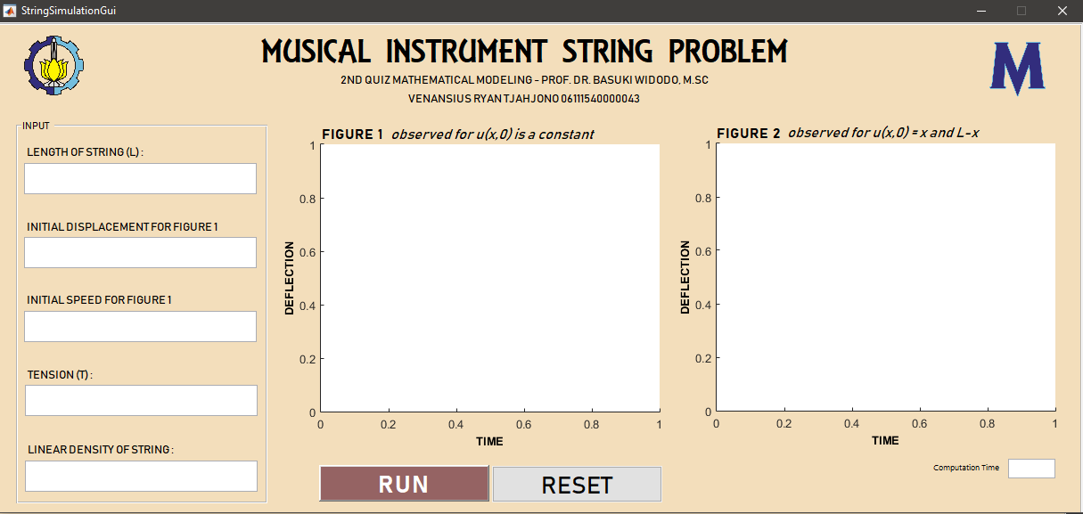

GRAPHICAL USER INTERFACE

SIMULATION RESULT FOR VARIOUS LENGTH

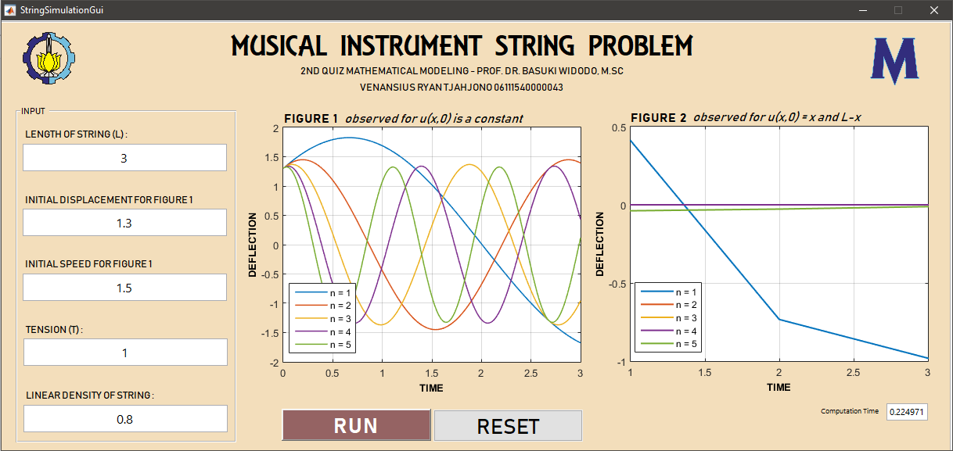

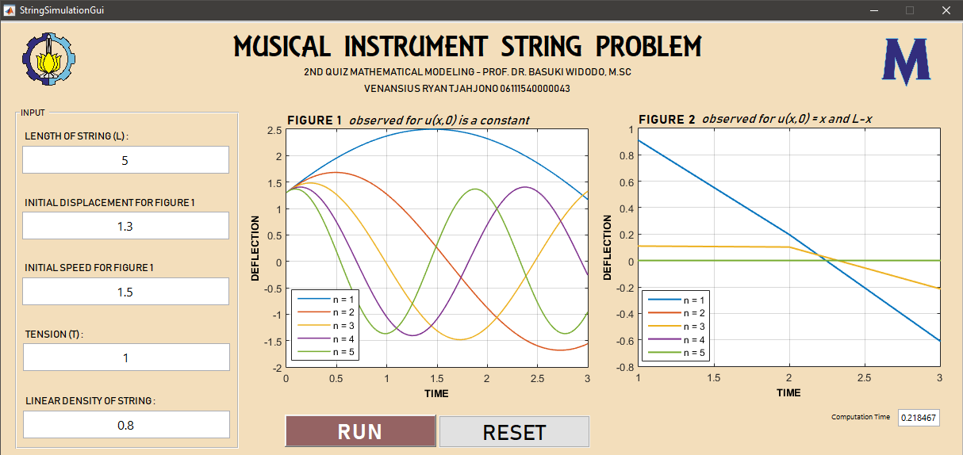

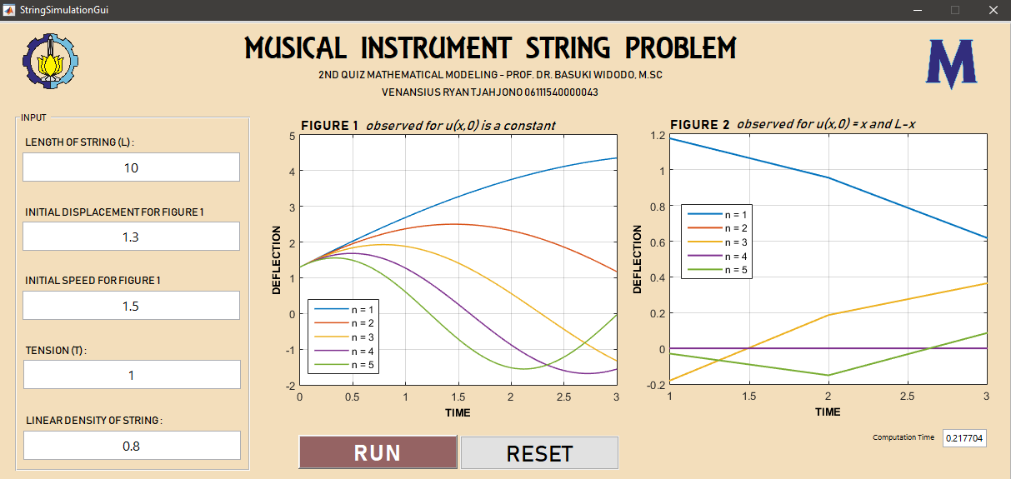

SIMULATION RESULT FOR VARIOUS TENSION 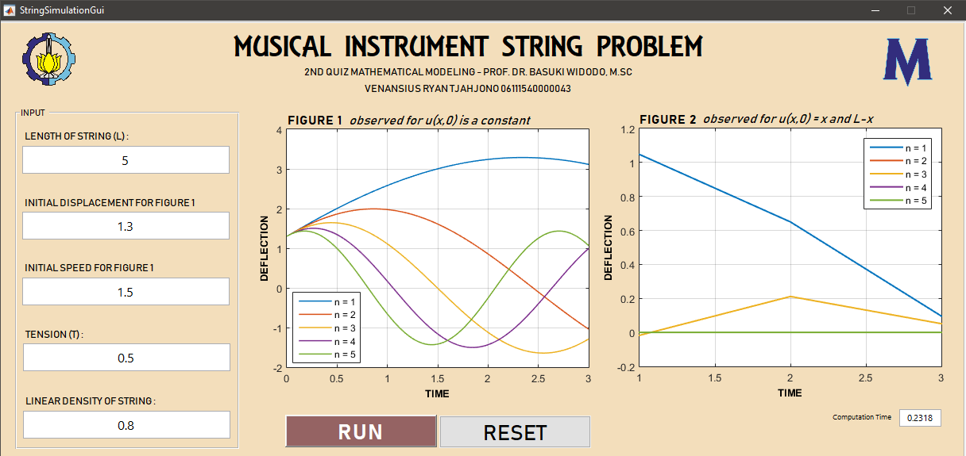

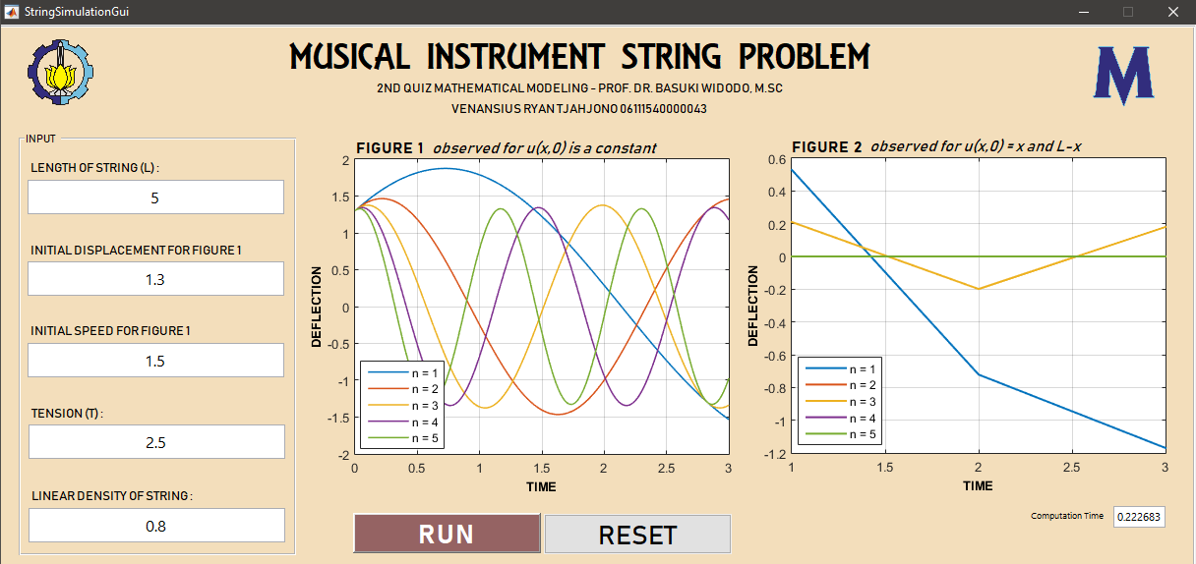

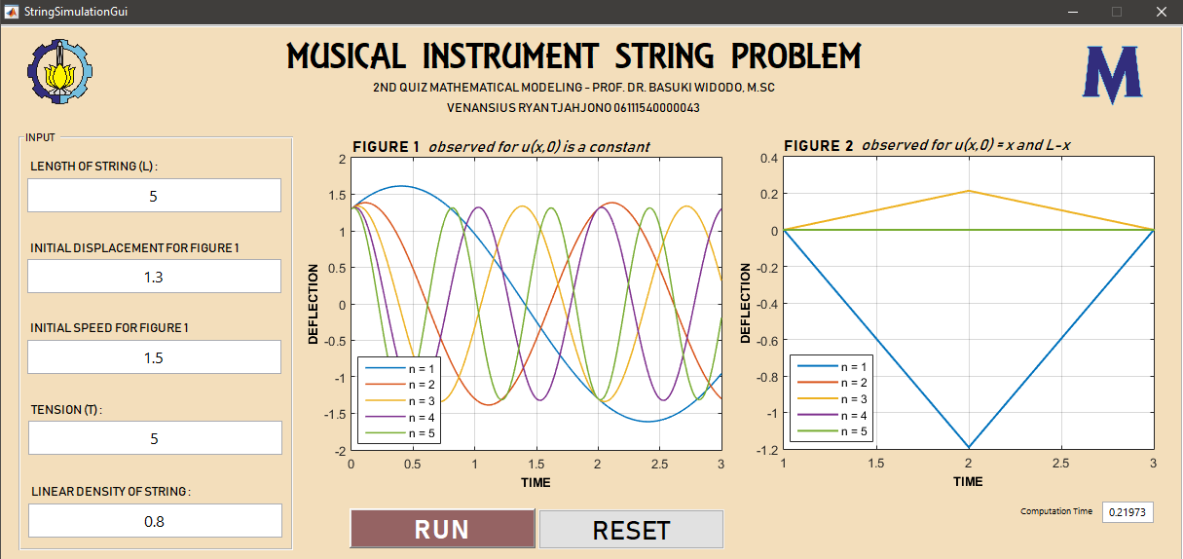

SIMULATION RESULT FOR VARIOUS LINEAR DENSITY (OR UNIT MASS/LENGTH)

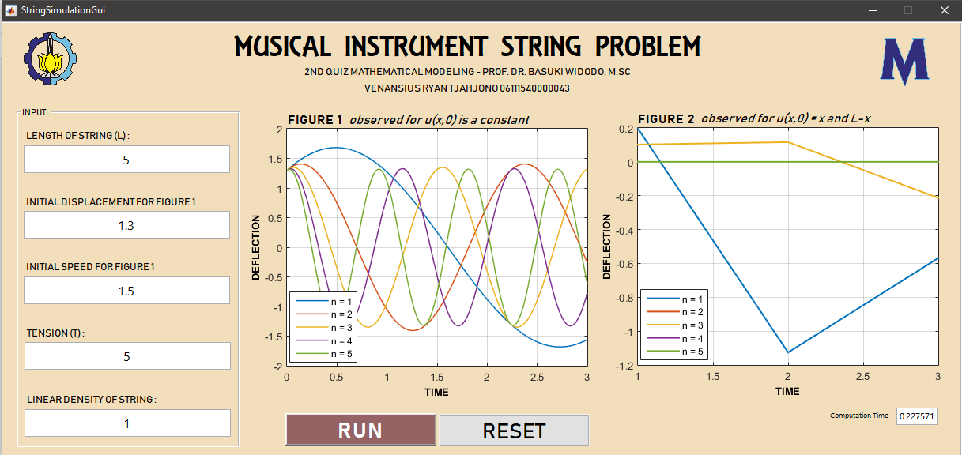

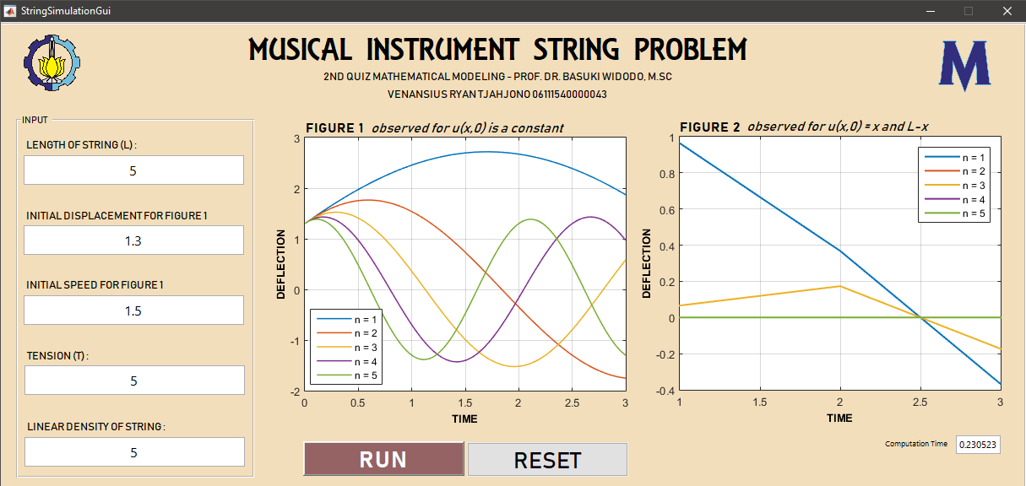

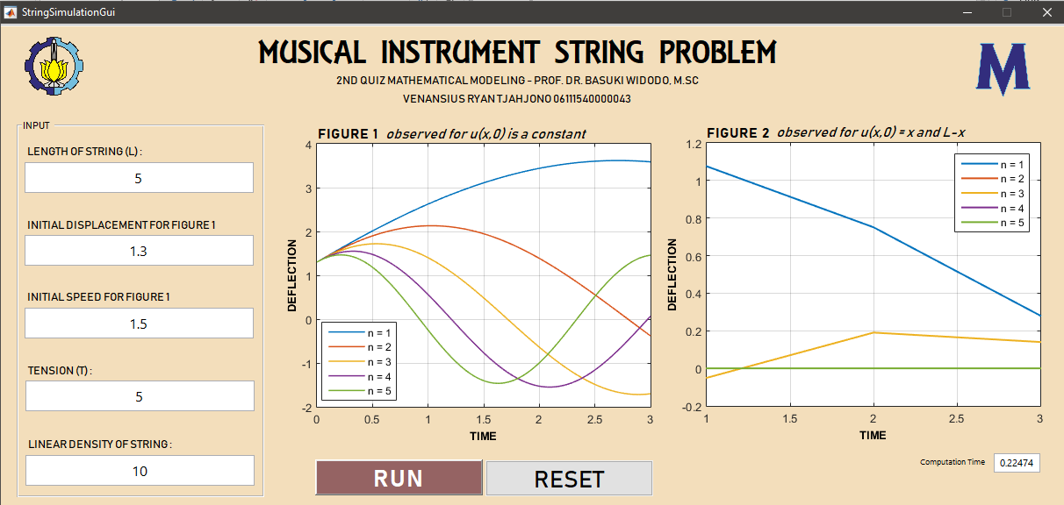

CONCLUSION

Wave patterns are produced by musical instrument string, as the result of the repeated interference of two waves of identical frequency while moving in opposite directions along the same medium. Most of musical instrument wave patterns consist of nodes and antinodes. Based to my simulation, it can be shown that:

1. Longer string cause decreasing frequency.
2. Bigger tension produces bigger frequency.
3. Bigger linear density produces lower frequency.